Protein Analysis (Structure & Properties)
1.⁠ ⁠Molecular weight, pI, instability index, aliphatic index.
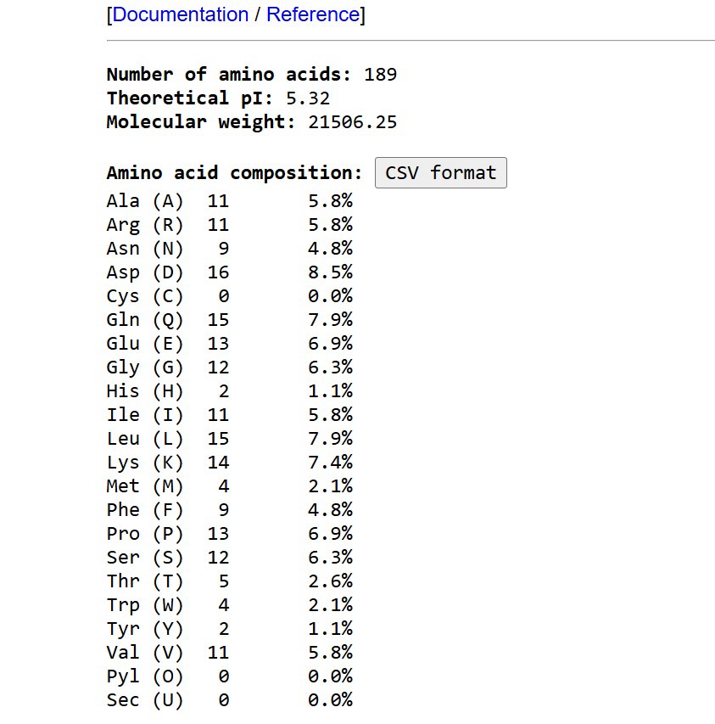
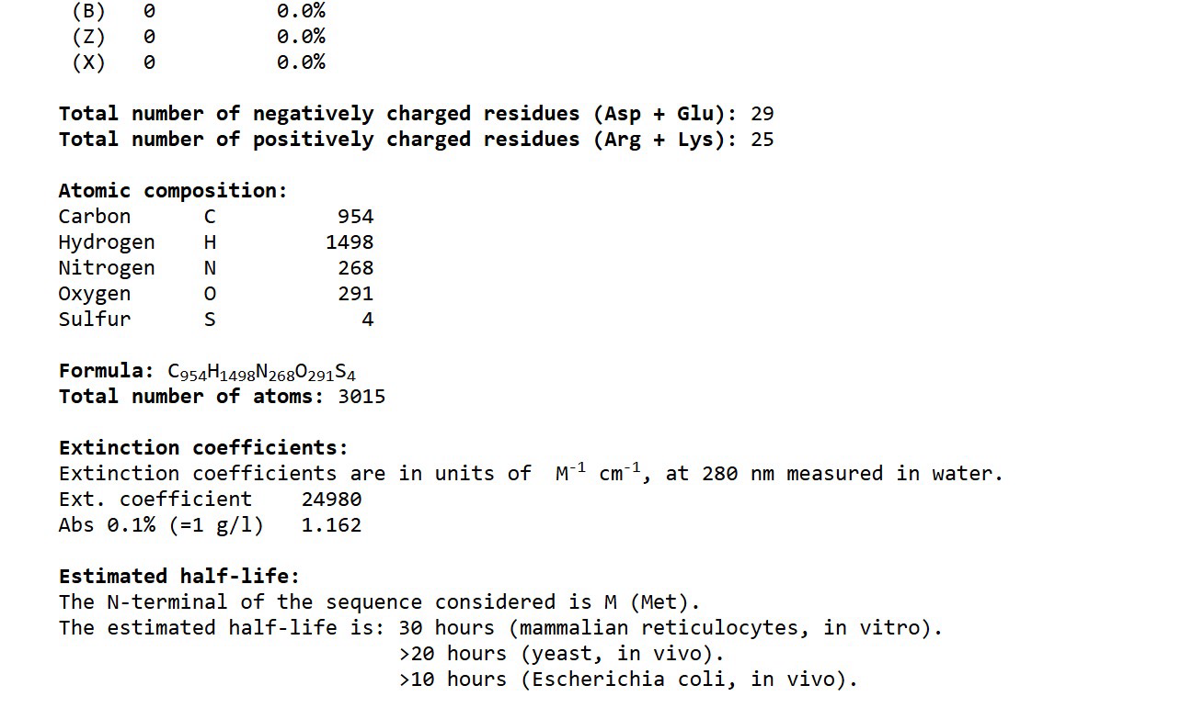
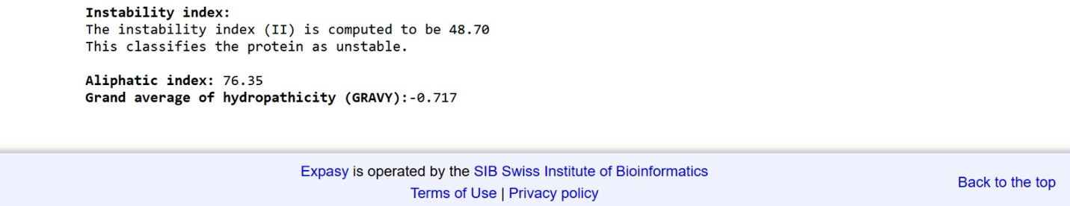

2.⁠ ⁠Domains and motifs (Pfam/InterPro).
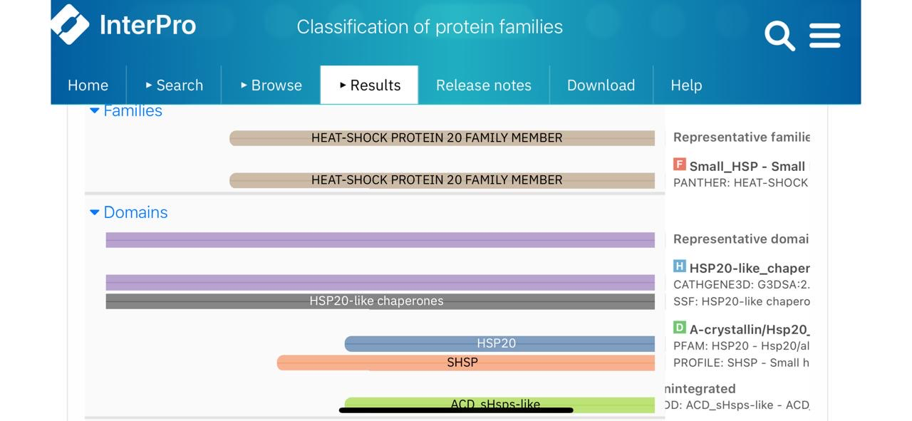

3.⁠ ⁠Secondary structure prediction.
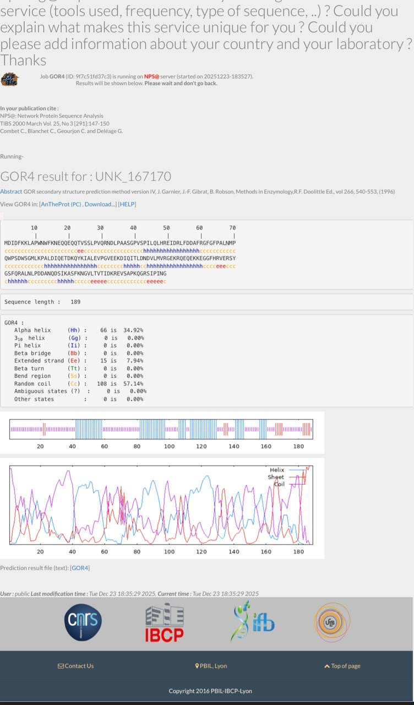

Functional predictions based on the detected domains
1.Molecular chaperone activity (ATP-independent)
- The HSP20-like chaperone / α-crystallin domain is characteristic of small heat-shock proteins.
- sHSPs bind partially unfolded proteins to prevent aggregation and misfolding, especially during heat or oxidative stress.
2.Role in cellular stress tolerance
- Members of the HSP20 family are typically up-regulated in response to:
  - Heat shock
  - Oxidative stress
  - Chemical or environmental stress
- They help maintain protein homeostasis (proteostasis).
3.Oligomerization and protein–protein interactions
- sHSPs usually form large oligomeric complexes.
- The ACD domain mediates dimerization and higher-order assembly, which is important for chaperone function.
4.Possible roles in cytoskeleton and apoptosis regulation (context-dependent)
- Many HSP20 proteins interact with cytoskeletal proteins, stabilizing filaments under stress.
- Some members modulate cell survival and stress signaling pathways.

Predicted Functional Summary
- Small heat-shock protein (HSP20 family)
  - Contains an HSP20-like / α-crystallin chaperone domain characteristic of sHSPs.
- ATP-independent molecular chaperone
  - Binds partially unfolded or misfolded proteins.
  - Prevents protein aggregation during cellular stress.
- Stress-response and proteostasis role
  - Likely up-regulated under heat shock, oxidative, or environmental stress.
  - Helps maintain protein stability and folding homeostasis.
- Oligomerization & protein-protein interaction
  - Forms dimers and higher-order oligomers, which are required for chaperone activity.
- Potential regulatory roles (context-dependent)
  - May interact with cytoskeletal components.
  - Can modulate cell survival / stress signaling pathways in some organisms.

Table of protein properties
Property | Prediction / Value | Evidence / Source
Protein family | Heat-shock protein 20 (HSP20) family member | InterPro – Family classification
Functional class | Small heat-shock protein (sHSP), ATP-independent molecular chaperone | InterPro – HSP20 / α-crystallin domain
Primary function | Prevents aggregation of unfolded proteins during stress; stabilizes proteins | InterPro – HSP20-like chaperones
Domain architecture | HSP20 / α-crystallin domain (ACD) | InterPro domains: HSP20-like chaperones, SHSP, A-crystallin/Hsp20
Likely biological role | Stress response, proteostasis, cytoprotection under heat/oxidative stress | InterPro functional inference
Oligomerization tendency | Forms dimers and higher-order oligomers | Known behavior of sHSP / ACD domain proteins (domain-based inference)
Sequence length | 189 amino acids | GOR4 result
Secondary structure composition | ~34.92% α-helix; ~8.94% β-strand; remainder coil | GOR4 secondary-structure prediction
Helix-rich regions | Prominent helices across central region | GOR4 helix profile
Sheet-containing regions | Short β-strands mainly in core domain | GOR4 strand profile
Structural organization | Flexible N-terminal region + conserved ACD core | Combined domain + GOR4 inference
Subcellular localization (likely) | Cytoplasmic (typical for sHSPs) | Functional/domain inference

